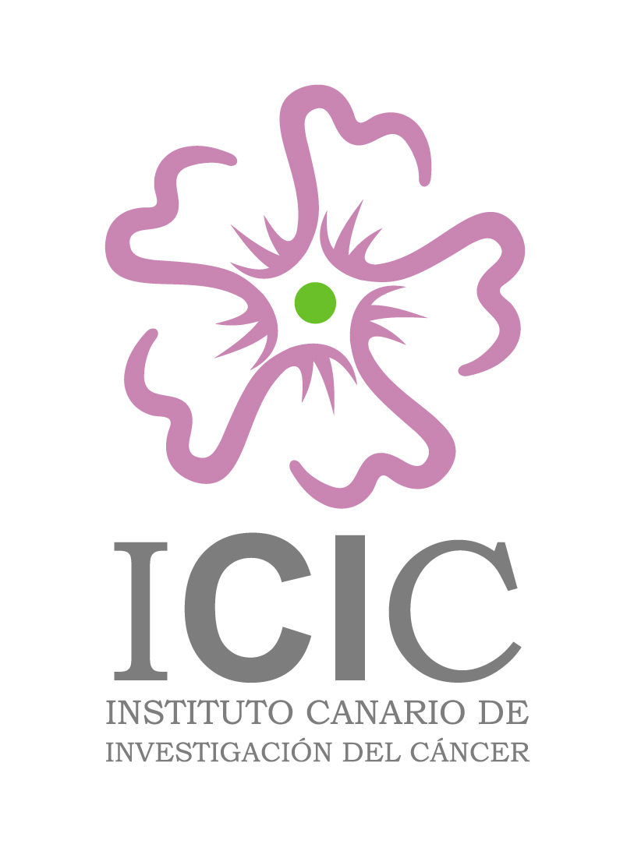

INSTITUTO CANARIO DE INVESTIGACIÓN DEL CÁNCER
RNICC´04

Final Programme

Thursday, 16th December
Morning
Arrival to La Palma, Hotel Teneguía Princess, Fuencaliente | 11:00
Poster session: First year ICIC fellows and submitted abstracts  Cecilia Guzmán Bistoni  “Lobular carcinoma of the breast and E-cadherin gene activation; an inmunohistochemical review of the origin of that neoplasia”  Fátima Gutiérrez Nicolás  “Modification of biosynthetic pathways for the accumulation of anti-tumour compounds”  Clara Guayarmina Hernández Rodríguez  “Long-Tern study of the toxic effects exerted by the consumption of nonylphenol and 4-octylphenol – contaminated water in rat”  Eva Betancor Hernández  “Polymorphic genes linked to the synthesis or degradation of estrogens in breast cancer”  Carlos Mateos Díaz  “Purification of GST-Fusion Proteins and their application to explore the role of GTPases in Growth Hormone signalling pathways”  Ainara Martínez Arín  “Statin in the therapy of chondrosarcoma: Study in vitro”  Germán Rodríguez González  “Short CAG and GGN repeats in the androgen receptor gene are associated with more benign forms of endometrial cancer  Nuria Cabrera Benítez  “No-tumoural effect of Statins in the treatment of osteosarcoma. In vitro study”  Laura López Ríos  “Inluence of PAI-1 and ACE on several predictor variables in endometrial cancer”  Dionisio Lorenzo Villegas  “Role of ras/rap in the p38 MAPK-mediated induction of NOS-2 in astrocytes and its supression by adenine compounds”  Yeray Díaz Díaz  “Biocancer.com: a virtual Journal form the ICIC”  Raquel Cruz Dorta  “Tumors register at Hospital Univ. Ntra. Sra. de Candelaria”  Nache Musa  “Breast cancer database of Las Palmas hospitals“  Last minute abstracts  Chairpersons: Eduardo Blasco and Sergio Moreno | 11:00 to 13:00
OPENING SESSION  Canary Islands, La Palma and Academic authorities  The ICIC direction  Reception | 13:00  14:00
Thursday, 16th December
Afternoon
First session: ANTITUMOR COMPOUNDS (I)  Patricia Cruz López (15´)  “Advances in the study of dsp toxins”  Juan Francisco León Oyola (15´)  “Improved processes for the isolation and synthesis of new drugs from natural sources”  David Tejedor Aragón (25´)  “Application of Multicomponent Reactions and Domino Processes to the Síntesis of New Anticancer Agents”  Elisa Pérez Sacau (25’)  “Chemo-modulation of naphthoquinones as new anticancer agents”  Chairpersons: Miguel Fdez. Braña and Sergio Moreno | 16:00 to 18:00
Coffee break | 18:00 to 18:30
Second session: ANTITUMOR COMPOUNDS (II)  Raquel Díaz Peñate (25’)  “High antitumoral activity of lapachol derivative compounds”  José Manuel Padrón (25’)  “Anticancer drug evaluation”  Rubén Pérez Machín (25’)  “Estrogen effects in vitro and in vivo on osteosarcoma cells lines UMR-106 and HOS”  Martina Pec (25’)  “Integrin bidirectional signaling in mechanisms of apoptosis induced by dehydrothyrsiferol in human breast cancer and proliferating endothelial cells”  Chairpersons: Miguel Fdez. Braña and Frank Uhlmann | 18:30 to 20:30
Dinner at the hotel  Sccial activities  Music Show | 20:30 h
Friday, 17th December
Morning
Third session: TUMOR GENOMICS AND MARKERS  María Pilar Cárdenes Bilbao (15’)  “Lymphocyte molecular profiles in cancer and its predictive role for treatment response”  Elisa Bordón Rodríguez (15’)  “Predictive factors for tumor response and normal tissue damage after irradiation for Cervix carcinoma and Oral carcinoma patients”  Ricardo Reyes Rodríguez (25’)  “Molecular bank of tumours: Study of different topics to the neoplasic illness”  Raquel Ramírez Moreno (15´)  “Microsatellite instability and hMLH1 promoter methylation in endometrial cancer”  Cristina Bilbao Sieyro (25’)  “Optimisation of DNA and RNA extraction from archival formalin-fixed, paraffin-embedded”  Chairpersons: Sergio Moreno and Jon Pines | 9:00 to 11:00
Coffee Break | 11:00 to 11:30
Fourth session: APPLIED CANCER RESEARCH  Delia Murias Rubio (15’)  “Psychological support to improve life quality in women with breast cancer and the family of patients with cancer”  Raúl Hernández Aguiar (15´)  “Organization and management in experimental animals”  Antonio Cabrera (25´)  “ The CDC of the Canary Islands”  Leandro Fernández (25´)  “Progress in expression chips tecnology”  Chairpersons: Félix Bonilla and Pedro Lara | 11:30 to 14:00
Lunch | 14:00 to 16:00
Friday, 17th December
Afternoon
Fifth session: Invited speakers  Jon Pines  “Regulating mitosis by proteolisis”  Frank Ulhmann  “Chromosome segregation during mitosis”  Félix Bonilla  “Genetic regulation of vitamin D receptor on colon cancer”  Chairpersons:  Sergio Moreno, Javier Dorta and Nicolás Díaz Chico | 16:00 to 18:30
Coffee break | 18:30 to 19:00
Meeting of the ICIC members | 19:00 to 20:30
Dinner  Place to be announced | 20:30
Saturday, 18th December
Morning
Option A:  Los volcanes route (recommended).  A 6 hour walk for the most recent volcanic area of La Palma (optional)  An opportunity for taking to the visiting scientists.  Option B:  Morning: Swimming pool and lunch at the hotel  Afternoon: Guided siteseeing La Palma, Visiting telescopes at Roque de los Muchachos  Both options:  Diner at the Restaurante La Pradera (Barlovento) | 08:00 h  13:00 h  20:00 h
19th december, Sunday
Morning

Back to home

