
Unión Europea
Fondo Social Europeo
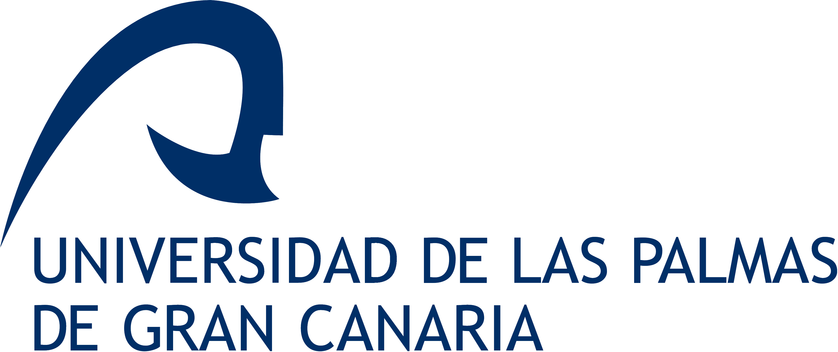

INSTITUTO CANARIO DE INVESTIGACIÓN DEL CÁNCER
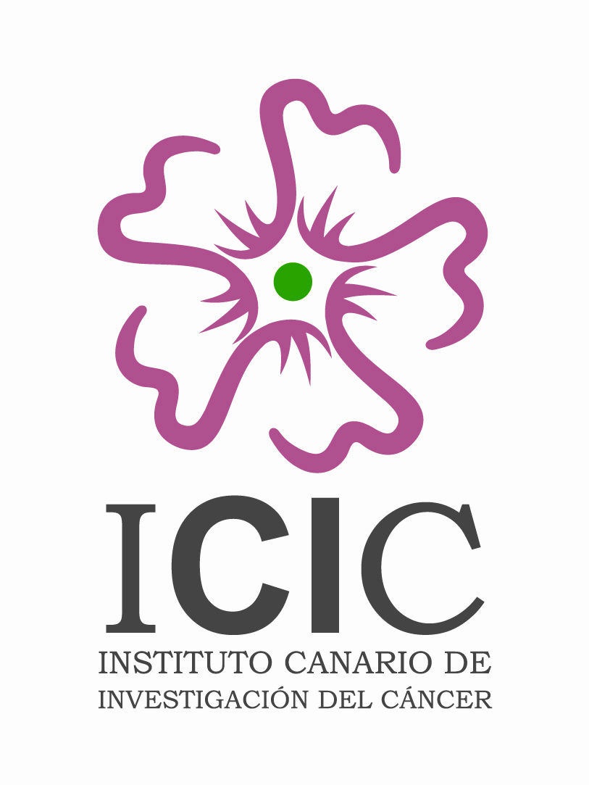
3rd Meeting YCIC
Young Cancer Investigators of the Canary Islands
1st Meeting YBIM
Young Biomedical Investigators of the Macaronesia

November 9-10th, 2006
Instituto Universitario de Bio-Orgánica Antonio González
University of La Laguna, Tenerife, Canary Islands
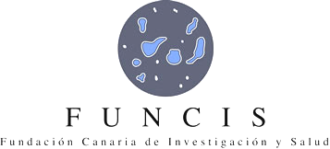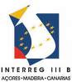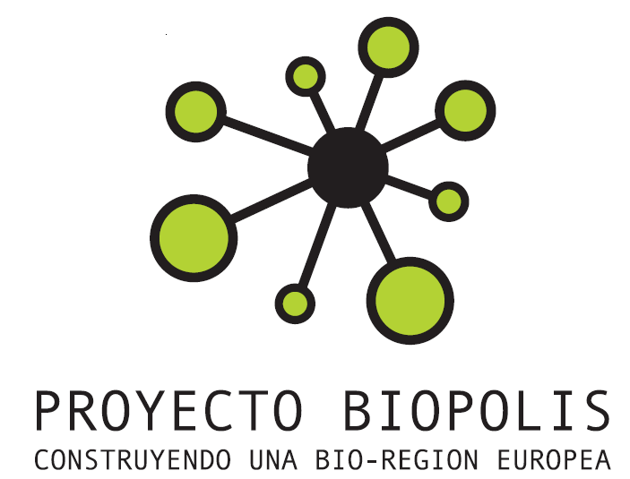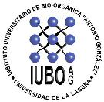
Scientific Committee
Chairman: Sergio Moreno, CIC Salamanca
Víctor S. Martín, ULL | Paula Castilho, UMA, Madeira
Enrique Martínez, ULL | Manuela Lima, UA, Azores
Ángel G. Ravelo, ULL & ICIC | Miguel Fernández Braña, CEU, Madrid
Antonio Cabrera de León, ULL & ICIC | Nicolás Díaz Chico, ULPGC & ICIC
Javier Dorta Delgado, SCS & ICIC | Fernando García Tellado, CSIC
Local Organizing Committee
José M. Padrón, Rubén P. Machín, Leticia G. León, María C. Vega (BioLab, ICIC & ULL)
Raquel Ramírez, Germán Rodríguez (ICIC – ULPGC)
Víctor Díaz Viera (FUNCIS), Francisco Puertas (ICIC)

PROMETEO Coordinator
Rafael Zárate (ULL & ICIC)

Co-Organized by
Gobierno Autónomo de Canarias
Cabildo de Tenerife
Fundación Canaria de Investigación Sanitaria (FUNCIS)
Instituto Canario de Investigación del Cáncer (ICIC)
University of La Laguna (ULL)
University of Azores (UA)
University of Madeira (UMA)
University of Las Palmas (ULPGC)
OBJECTIVES:

- Facilitate Young Biomedical Researchers of the Macaronesia to communicate their scientific results in a friendly environment.
- Encourage young and senior biomedical Macaronesian researchers to cooperate in the development of new projects.
- Obtain the expert advice from six world-class invited biomedical scientists.
- Start up a Biomedical Research Network in the Macaronesia that will increase the success of future projects nucleated at the islands.

REGISTRATION
Participation as speaker in this Meeting will be by invitation of the Organising Committee.
Participation with a poster is offered to any young biomedical investigator (<40 yrs), with preference to those working in the Macaronesian islands.
A limited number of travel grants are available. Please contact with the following persons:

Azores: Dra. Manuela Lima, mlima@notes.uac.pt
Madeira: Dra. Paula Castilho, castilho@uma.pt
Canarias: José M. Padrón, jmpadron@ull.es
Final Program

THURSDAY, NOVEMBER 9, 2006
Opening Ceremony  ICIC President , Organizing Committees, Academic authorities | 09:00-09:15
YCIC session: TUMOR GENOMICS AND MARKERS  Chairmen: Juan C. Díaz Chico and Jiri Bartek  Cristina Bilbao Syero (25’), ICIC, Las Palmas de Gran Canaria  Clinical relevance of microsatellites instability in endometrial cancer  Raquel Ramírez (15’), ICIC, Las Palmas de Gran Canaria  Differences among microsatellites instability, MGMT promoter methylation and Kras mutation in colorectal and endometrial cancers  Germán Rodríguez (15’), ICIC, Las Palmas de Gran Canaria  Possible clinical relevance of the combined effect of CAG and GGN androgen receptor gene polymorphisms in prostate cancer  Ana González Hernández (15’), ICIC, Santa Cruz de Tenerife  Androgen receptor polymorphisms and breast cancer risk  Elisa Bordón Rodríguez (25’), ICIC, Las Palmas de Gran Canaria  Apoptosis, proliferation and genetic regulation (p53, Bax, Bcl-2, Cyclin D1 and IGF-1R) in cervical carcinoma. Prediction of radio induced toxicity in normal tissue | 09:15–11:00
Coffee break | 11:00-11:30
YCIC session: EXPERIMENTAL AND BIOMEDICAL RESEARCH  Chairmen: Pedro Lara and Sergio Moreno  Clara Guayarmina Hernández Rodríguez (25’), ICIC, Las Palmas de Gran Canaria  Dietary exposure to environmental carcinogens: diet as a predictive model for serum organochlorine levels  Luis Alberto Henríquez Hernández (25’) ICIC, Las Palmas de Gran Canaria  Hormone-induced changes in the gene expression pattern in liver. Influence of epigenetic mechanism  Dionisio Lorenzo Villegas (25’), ULPGC, Las Palmas de Gran Canaria  Role of cAMP and p38 MAPK in the supression by ATP and adenosine of NOS-2 induction by cytokines in cerebellar rat astrocytes and C6 glioma cells  Cecilia Guzmán Bistoni (25’), ICIC, Puerto del Rosario  Leptins from endemic plants of the Canaries: searching for a non-human sialic acid molecule in stomach cancer | 11:30 – 14:00
LUNCH | 14:00–16:00
KEYNOTE LECTURES (I) | 16:00-21:00
Sergio Moreno, CSIC, Salamanca
Unraveling the mechanism of action of the antitumour drug Yondelis
Juan Carlos Tercero, PharmaMar, Madrid
Molecular markers of response to Yondelis
Marcos Malumbres, CNIO, Madrid
Regulation of the cell cycle by kinases and phosphatases: opportunities for therapeutic intervention

FRIDAY, NOVEMBER 10, 2006
YCIC / YBIM session: ANTITUMOR COMPOUNDS  Chairmen: Ángel Ravelo and Jim Bischoff  Patricia Cruz López (15’), ICIC, La Laguna  19-epi-okadaic acid, a new PP1 and PP2a inhibitor  José M. Padrón (25’), ICIC, La Laguna  Fe(III)-promoted one-pot synthesis of novel marine antiproliferative drug analogs | 08:45-09:30
YBIM session: INVITED SPEAKERS (I)  Chairmen: Leandro Fernández and Antonio Casado  Miguel X. Fernandes (25’), Univ. Madeira, Funchal  Molecular modeling of ligands – balancing specificity using computational methods  Enma Carmelo Pascual (25’), ULL, La Laguna  DNA segregation in bacteria: the parFG system | 09:30-10:30
Coffee break | 10:30-11:00
YBIM session: INVITED SPEAKERS (II)  Chairmen: Víctor S. Martín and Marcos Malumbres  Francisco J Navarro Rivero (25’), ULL, La Laguna  Postranslational regulation of a yeast nitrate transporter  Felix Machín (25’), Hosp. N.S. de Candelaria, Santa Cruz de Tenerife  Ribosomal DNA as a model to study genomic instability in cancer  José Quintana (25’), ULPGC, Las Palmas de Gran Canaria  Melatonin-induced apoptosis in the human leukemia cell line HL-60 | 11:00-12:30
Poster session (I)  Chairman: Nicolás Díaz Chico | 12:30-13:30
LUNCH | 13:30–15:30
KEYNOTE LECTURES (II) | 15:30–19:00
James R. Bischoff, CNIO, Madrid
Aurora Kinases: from gene to drug
Antonio Casado, Hosp. Univ. San Carlos, Univ. Complutense, Madrid
Hormonal Treatment of breast cancer
Jiri Bartek, Institute of Cancer Biology, Copenhague, Denmark
DNA damage checkpoints: Mechanism and involvement in human cancer
CLOSING CEREMONY OF THE COURSE ON ANTITUMOR AGENTS  Presidente del Gobierno de Canarias  Presidente del Cabildo de Tenerife  Rector de la Universidad de La Laguna  Director de la Oficina de Ciencia y Tecnología  Director del Programa Prometeo  Decano de Farmacia  Director del I.U. de Bio-Orgánica “Antonio González”  Director del I.U. de Enfermedades Tropicales  Director del IPNA CSIC  Director de FUNCIS  Presidente de la Fundación ICIC  Director del ICIC  Director del Curso de Antitumorales  Director Científico de la III YCIC / I YBIM  Presidente del Comité Organizador de la III YCIC / I YBIM | 19:00 – 20:00
DINNER | 21:00

SATURDAY, NOVEMBER 11, 2006

YCIC / YBIM session: PERSPECTIVES IN ANTITUMOR COMPOUNDS RESEARCH IN THE MACARONESIA  Chairmen: Eduardo Salido and Fernando G. Tellado  José M. Padrón, Leticia G. León, María C. Vega, ICIC, La Laguna  Resources of the BioLab for exploring antitumor activity of new compounds  Mario Díaz, ULL, Raquel Marín, ULL  Resources to study membrane effects of estrogens and antiestrogens.  Rubén Pérez Machín, ICIC, ULL  Resources to study steroid hormone-like effects of new compounds  José Quintana, ULPGC  Resources to study apoptotic activity of new compounds | 09:30 – 11:30
Coffee break | 11:30 – 12:00
YCIC / YBIM session: PERSPECTIVES IN ANTITUMOR COMPOUNDS RESEARCH IN THE MACARONESIA  Chairmen: Nicolás Díaz Chico and Leandro Fernández  Elisa Pérez Sacau ICIC, La Laguna, and Miguel X. Fernandes, Univ. Madeira, Funchal  Molecular modeling of ligands in antitumor drug discovery  Present and future projects on drug discovery based on the Macaronesian biodiversity.  Open discussion conducted by the chairmen.  Concluding remarks. | 11:30-13:30
Lunch | 14:00

